

AP® Physics C
1974 Free Response Questions

The materials included in these files are intended for use by AP teachers for course and exam preparation in the classroom; permission for any other use must be sought from the Advanced Placement Program®. Teachers may reproduce them, in whole or in part, in limited quantities, for face-to-face teaching purposes but may not mass distribute the materials, electronically or otherwise. These materials and any copies made of them may not be resold, and the copyright notices must be retained as they appear here. This permission does not apply to any third-party copyrights contained herein.

These materials were produced by Educational Testing Service® (ETS®), which develops and administers the examinations of the Advanced Placement
Program for the College Board. The College Board and Educational Testing Service (ETS) are dedicated to the principle of equal opportunity, and their
programs, services, and employment policies are guided by that principle.

The College Board is a national nonprofit membership association dedicated to preparing, inspiring, and connecting students to college and opportunity.
Founded in 1900, the association is composed of more than 4,200 schools, colleges, universities, and other educational organizations. Each year, the
College Board serves over three million students and their parents, 22,000 high schools, and 3,500 colleges, through major programs and services in
college admission, guidance, assessment, financial aid, enrollment, and teaching and learning. Among its best-known programs are the SAT®, the
PSAT/NMSQT®, and the Advanced Placement Program® (AP®). The College Board is committed to the principles of equity and
excellence, and that commitment is embodied in all of its programs, services, activities, and concerns.

APIEL is a trademark owned by the College Entrance Examination Board. PSAT/NMSQT is a registered trademark jointly owned by the College Entrance Examination Board and the National Merit Scholarship Corporation. Educational Testing Service and ETS are registered trademarks of Educational Testing Service.
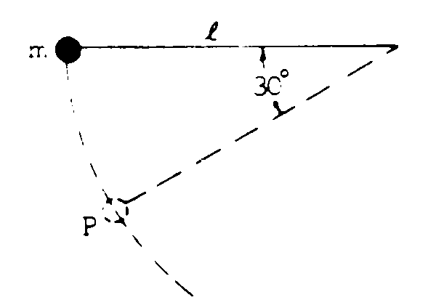
1974M1. A pendulum consisting of a small heavy ball of mass m at the end of a string of length l is released from a horizontal position. When the ball is at point P, the string forms an angle of 30° with the horizontal as shown above.
a. In the space below, draw a force diagram showing all of the forces acting on the ball at P. Identify each force clearly.

b. Determine the speed of the ball at P.
c. Determine the tension in the string when the ball is at P.
d. Determine the tangential acceleration of the ball at P.

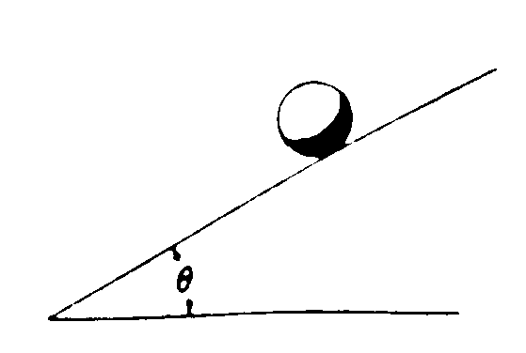
1974M2. The moment of inertia of a uniform uniform solid sphere (mass M, radius R) about a diameter is 2MR²/5. The sphere is placed on an inclined plane (angle θ)as shown above and released from rest.
a. Determine the minimum coefficient of friction μ between the sphere and plane with which the sphere will roll down the incline without slipping
b. If μ were zero, would the speed of the sphere at the bottom be greater, smaller, or the same as in part (a)? Explain your answer.

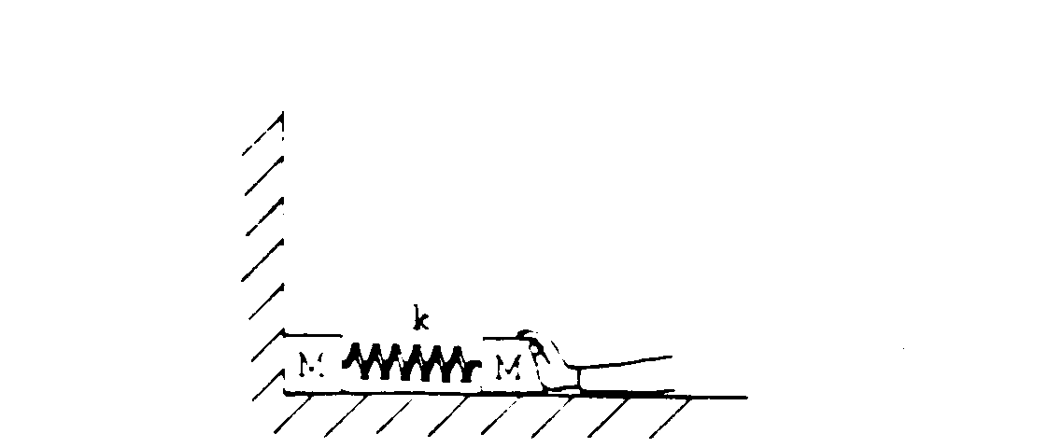
1974M3. A system consists of two blocks, each of mass M, connected by a spring of force constant k. The system is initially shoved against a wall so that the spring is compressed a distance D from its original uncompressed length. The floor is frictionless. The system is now released with no initial velocity.
a. Determine the maximum speed of the right-hand block.
b. Determine the speed of the center of mass of the system when the left-hand block is no longer in contact
with the wall
c. Determine the period of oscillation for the system when the left-hand block is no longer in contact with
the wall

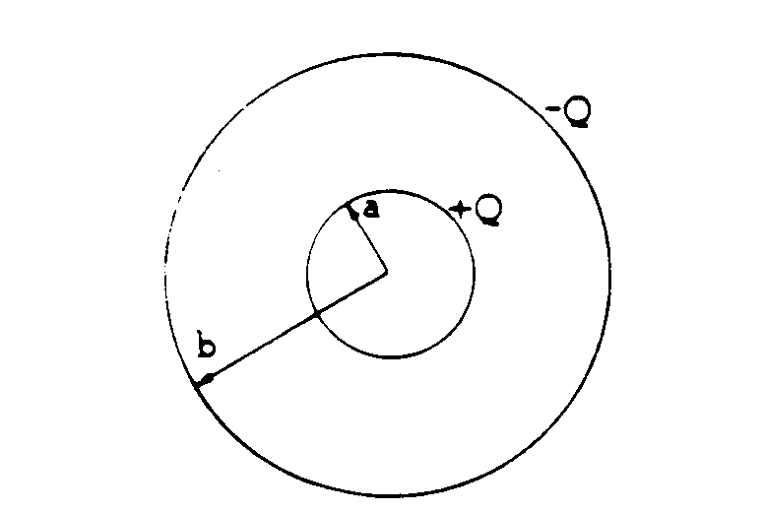
1974E1. Two concentric conducting spherical shells of radii a and b have charges of equal magnitude and opposite sign as shown above.
a. Determine the electric field at a distance r from the center Give separate expressions for r < a,
a <r <b, and r >b.
b. Determine the electric potential at r = b and at r = a, taking the potential equal to zero at infinity.

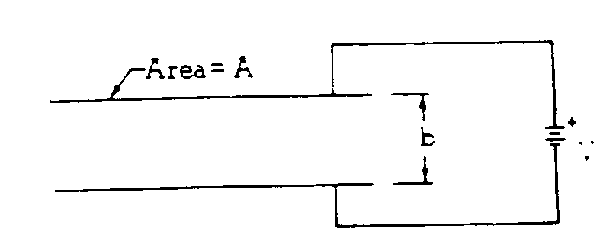
1974E2. A parallel-plate capacitor with spacing b and area A is connected to a battery of voltage V as shown above. Initially the space between the plates is empty. Make the following determinations in terms of the given symbols.
a. Determine the electric field between the plates.
b. Determine the charge stored on each capacitor plate.
A copper slab of thickness a is now inserted midway between the plates as shown below.
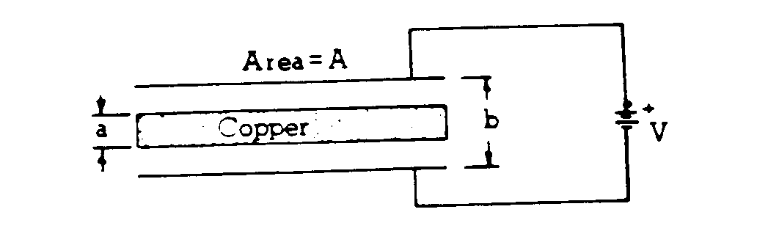
c. Determine the electric field in the spaces above and below the slab.
d. Determine the ratio of capacitances C_{with} _{copper} when the slab is inserted
C_{original}
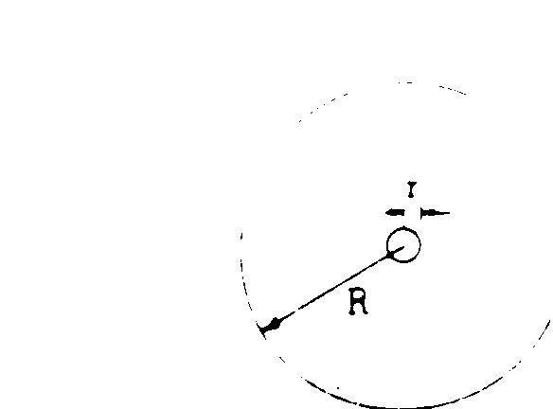
1974E3. A small circular loop of wire with radius r is placed at the center of a large circular loop of wire with radius R. The two loops lie in the same plane, and r << R. In the outer loop there is a sinusoidal current
I = I_{o}sinωt, where t is time and I_{o} and ω are constants.
Find an expression for the induced emf in the inner loop.

